St Andrews Old Course Special Offer;
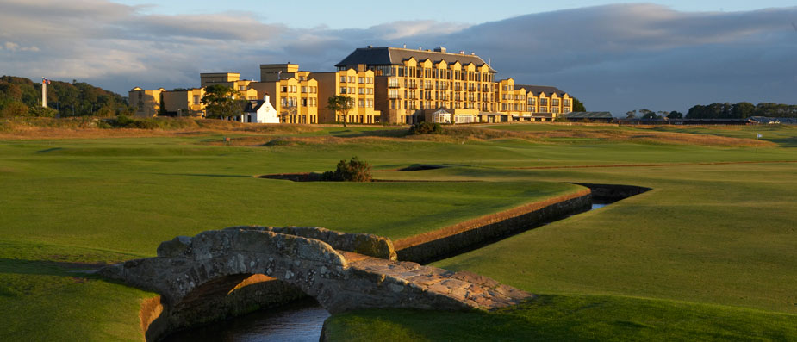
We are looking to give a SINGLE golfer the opportunity of a lifetime to experience St Andrews Old course.
This is a very special offer at a very special one off price…first come first serve
TOUR INCLUDES;
Accommodation;
3 Nights, St Andrews Guest House including breakfast;
Golf;
St Andrews Old Course, Tee time 13.30;
St Andrews Castle course, Tee time 11.20;
Extras;
Meet & Greet at airport of arrival;
24/7 concierge service;
Complimentary warm up session on golf range on all aspects of the game with John Scott PGA Professional;
On Course help and guidance with John Scott PGA Professional;
Driving range fees and balls included;
All travel transfers throughout your stay in Scotland;
All preferred tee times booked;
All restaurant reservations booked in advance;
Complimentary bottled water, muesli bars & bananas;
Tour Itinerary;
19th July – Pick up from Edinburgh/Glasgow Airport, transfer to St Andrews;
20th July – Warm up session on golf range, St Andrews Old Course, Tee time 13.30;
21st July– Warm up session on golf range, 18 Holes St Andrews Castle Course, Tee time 11.20;
22nd July - Transfer to Edinburgh/Glasgow airport;
Total price;
Single Occupancy - € 1495,- excl. flight
Not Included;
Flights to and from Scotland; We are very happy to book the best available flight for you!
Travel Insurance;
Lunch, dinner and drinks;

